HOW TO CENTRE YOURSELF
AUG 09. 2026
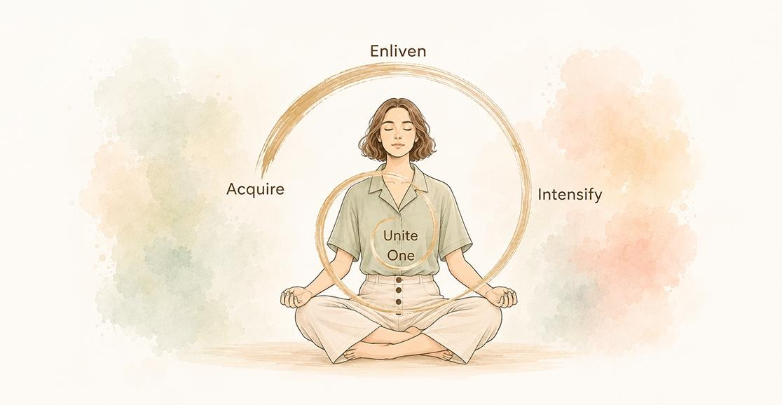
Dear friends,
Watch a potter at her wheel. Before there is any question of shaping a bowl, a cup or a diya, she does something that looks like nothing at all. She presses the clay to the centre of the wheel and holds it there. The wheel spins, her hands stay still, and slowly the wobbling lump of clay becomes quiet. Potters say that everything depends upon this moment. Clay that is off-centre may still be shaped, but the faster the wheel turns the more violently it trembles, until it flies apart in the potter’s hands. Clay that is centred can become anything, and it is the same for us. So, what is it in us that corresponds to the potter’s hands?
The practice of centring
Before we answer that question, let’s review the practice of centring. For many years, we have begun our workshops and training programmes with a moment of centring. Many of you have asked for the text of this simple exercise:
Centring: Observe your current attitude, gently turn your attention towards the heart and become aware of your inner condition, resting there in the remembrance of the Divine.
This one sentence takes less than a minute to do. What actually happens inside that minute? What is the anatomy of this small act? For reasons that will become clear, we anchor it in the five vowels of our alphabet, A, E, I, O, U. For a meditator, it is vital first to Acquire a spiritual condition, then to Enliven that state, Intensify it, become One with it and remain United with it. Let us take them one at a time.
Acquire. The word is chosen with care. We do not create a spiritual condition, any more than a window creates sunlight. The condition is always offered. In the Heartfulness way it is offered with particular tenderness through pranahuti, the Transmission that awaits every heart that turns inward. Our part is to receive. The moment we go into the heart, something is already there: a quietness, a softness, a weight of peace, however faint. To acquire is to notice and accept it, the way an open hand accepts rain. Most people go through life missing the inner conditions they are offered, because no one ever told them to collect what is being given.
Enliven. A condition acquired and then ignored fades like an ember left in the wind. To enliven it is to breathe gently upon that ember. We rest our attention on the state, feel its texture and let it spread through us. Whatever we attend to grows; this is the oldest law of the inner life. The condition that seemed a mere trace begins to glow.
Intensify. We make it intense but not by force. Intensity in the inner world never comes from clenching. It comes from interest ripening into love, the way a mother’s attention towards her sleeping child is effortless and total at the same time. As love for the condition deepens, the faint becomes vivid, the vivid becomes luminous, and the state that once required all our care now holds us of its own accord.
Oneness. We become one with it. Until now there were two, the condition and the one enjoying the condition. Here the distance between them thins and dissolves. We no longer have peace; we are peace. The enjoyer disappears into the enjoyed, and what remains can no longer be called an experience, for there is no one left standing apart to experience it.
Union. We remain united with that state. With this final vowel, the practice steps out of the moment and into the day. The condition is not to be left behind on the meditation cushion like a garment removed at the door. It comes with us, underpinning our meetings, the traffic and the cooking, a constant undertone beneath the melody of activity.
And why vowels? Try to pronounce a consonant on its own. K, t and p refuse to sound until a vowel joins them. Our duties, errands and engagements are the consonants of any day, necessary and structural and utterly unpronounceable by themselves. The acquired condition is like the vowels. Thread them through the consonants and the same ordinary day begins to speak.
One movement, many names
There is a family of words that we use almost interchangeably: focusing, centring, being centred, interiorization, internalization and becoming meditative. They are all related but they are not twins. It is worth climbing this ladder slowly, because each word marks a real stage on the way in.
Focusing is the outermost rung. It is an act of the mind where attention is narrowed to a beam and pointed at an object. A surgeon focuses, an archer focuses and an accountant focuses. Focus itself is neutral; it borrows its worth from its object. It also costs effort, which is why it tires us. To focus is to hold the mind the way we hold a torch. The grip cannot loosen for a moment.
Centring begins when focus changes direction. The beam turns away from objects altogether towards the subject, the one who was focusing. Unlike focus, which may fix upon anything, centring has only one destination. We do not centre on something; we centre in something.
Interiorization names the direction of this travel. Consciousness withdraws from the five outer doors, the movement the Yoga Sutra calls pratyahara, the way a tortoise draws in its limbs, the way attention comes home from the street at dusk. Yet it is still a movement and there is still something happening.
Internalization is subtler and here the vocabulary deepens. While interiorization moves attention, internalization transforms being. The truth we have heard remains information. A truth we practise becomes a habit. A truth internalized becomes us. It is like dyeing cloth. When we dip the cloth briefly the colour sits on the surface and the first wash removes it. When we let the cloth soak until the dye permeates the fibres, we cannot separate the colour from the cloth without destroying both. Similarly, remembrance begins as an exercise we perform and ends as the fabric of our being.
Being centred is a state, not an act. Centring is the visit while being centred is the residence. We may centre ourselves a dozen times a day, and we should, but a day comes when the returning has quietly become a remaining, and we discover we no longer need to go to the Centre. We live there and go out from it on errands.
And being meditative? Here language reaches its most delicate rung. A meditative state is not confined to closed eyes. It pervades walking, working, listening and speech. And observe how carefully we must say ‘arriving at a meditative state’ rather than ‘having arrived’. We are always arriving because the state is always receding. When we walk towards the horizon it retreats; when we walk further it retreats further. But it is the horizon inviting us, not mocking us. Because the Centre is infinite, the state that reflects it deepens without end. A goal that can be reached, finished and filed away is a finite goal, unworthy of the soul’s appetite. So, arriving is the permanent tense of the seeker. Never finishing to arrive is the signature of an infinite Beloved.
When you look once more at the five vowels, you will see how they climb the whole ladder. To acquire a condition, attention must first reverse its direction. Focus turned inwards means centring has begun. To enliven and intensify it is interiorization deepening, the tortoise settling further into itself. To be one with it is internalization, the dye entering the last fibre. And to remain united with it during the daily traffic, conversation and work is nothing other than the meditative state, the horizon we are forever arriving at. With these five vowels, the entire inner journey is rehearsed in miniature.
Why the Centre?
Babuji Maharaj expressed the whole science in two sentences:
‘Meditation really means that the mind becomes accustomed to the Centre itself instead of wandering elsewhere. Meditation on the heart is prescribed for that purpose.’
Notice that Babuji does not say meditation means stopping thoughts, achieving stillness or manufacturing peace. He says the mind becomes accustomed to the Centre. It becomes habituated, at home there. A mind wanders because it has made its home on the periphery, in objects, opinions and anxieties. When you give it a truer home, the wandering resolves itself, the way a river stops meandering when it finds the sea.
Babuji called this destination the innermost central point, the seat of the soul. It has been present in us since the dawn of creation. We have not been carrying it all these years; it has been carrying us. We fail to recognize the Centre, though it is always present, only because we are absorbed in the surface activity of the mind.
The ancient rishis folded this wisdom into language itself. The Sanskrit word for health is svasthya, built from sva, meaning ‘one’s own Self’, and stha, meaning ‘established’ – to be established in oneself. They were telling us that to be healthy is to be self-situated. A person can carry flawless medical reports and still be asvasthyaor dis-established, scattered across worries, screens and yesterday’s arguments. And we all know the opposite, someone whose body is failing yet who radiates a wholeness that fills the room. Language remembers what medicine is now rediscovering, that equilibrium is not only one of the benefits of being centred, it is the very definition of health. When we wish someone ‘swasth raho [stay healthy]’, we are in truth wishing them to remain established in themself.
There is an important distinction to be made: having a Centre does not automatically make us centred. Every one of us possesses this innermost point, yet how many of us live from it? Centredness is present to the extent that our consciousness is settled on the Centre. Focusing on the Centre is the consciousness equivalent to supporting a physical object’s point of balance. It is the source of personal equilibrium. When our focus is instead diverted from the Centre and skews towards less essential levels of existence, we become unstable. We become vulnerable. In such moments our weaknesses reveal themselves and we backslide.
This explains something we have all puzzled over. Why do the old tendencies return just when we thought we had outgrown them? Why does anger flare in a person who has meditated for twenty years? It is not that the practice has failed. It is that consciousness has drifted off-centre in that moment. Returning to the analogy of the potter’s wheel, the clay has slipped in the potter’s hands and the spinning of daily life does the rest. The fault is not in the wheel or in the clay but in the drift.
The pace of the periphery
Now, let’s become aware of something we passed over earlier. Every point on a wheel completes one revolution at the same time, yet not every point works equally hard. A speck of clay near the hub barely stirs; it traces a small, calm circle and it is done. In contrast, a speck at the rim must race, covering many times the distance in the same breath of time. It is the rim that flies apart first when the wheel spins too fast. The farther we are from the centre, the faster we must move merely to keep up.
The heavens teach the same law on a grander scale. Venus lives close to the Sun and so completes her circuit in about seven months. The Earth needs a year. Saturn, wandering far out in the cold, takes twenty-nine years to accomplish a single revolution, and were he to insist on keeping pace with Venus, and staying in line with her and the Sun, he would have to tear across an orbit nearly ten times as wide at a speed no planet could sustain. There is always a price for distance from the centre, either in frantic velocity or in long, cold delay.
Is our inner life any different? The farther our consciousness drifts from the Centre, the more furiously we must move to feel even faintly in tune with it. A life lived at the periphery, focused on possessions, positions and opinions, becomes a life of running. It requires more stimulation, achievement and reassurance, with each circuit longer than the last, each satisfaction briefer. We call it the pace of modern life but the stress and exhaustion are not really from overwork. They result from distance. The one who lives near the Centre hardly moves at all; a single thought of the Divine completes the circuit, the way the speck of clay near the hub completes its circle with a quiet, effortless turn. And what happens at the very Centre? The Sun does not orbit anything. It simply shines, its stillness feeding all the motion around it. And so it is with one who is established in the Centre; there is the least movement and the greatest radiance.
The simple solution
This awareness gives us great encouragement and hope. If our weaknesses show themselves only when we are off-centre, then we need not wage war against each weakness one by one. That war is exhausting. Also, the qualities we are fighting have a way of feeding on the attention we give them. The simpler way is to return to the Centre. A mind settled on the Centre provides no food for jealousy and no oxygen for resentment. Negative qualities are not so much conquered as vacated and positive qualities have no need to be forced. Courage, generosity and patience are the natural radiance of a consciousness at rest in its Centre, just as warmth is the natural radiance of a flame.
So, we may shun the negative with confidence, because we are not fighting it but simply refusing to live in its neighbourhood. And we may embrace the positive with courage, because it is already ours, waiting at the Centre for us to claim it.
Centred yet engaged
There is an old doubt that often remains: Does turning inwards mean turning away? Must we withdraw from family, work and responsibilities to be centred?
On 12 January 1946, revered Lalaji Maharaj intercommunicated from the Brighter World and shared a Persian couplet with Babuji Maharaj:
Nami goyam ki az duniya juda bash!
Bahr kare ki bashi ba Khuda bash.
I do not ask you to be away from the world,
only to attend to everything with a conscious idea of the Divine.
This is a prescription for balanced living. It describes an engaged centredness. The potter does not stop the wheel in order to centre the clay. She centres it while the wheel spins. Our wheel is the world – the office, the kitchen, the traffic, a difficult relative and an unfinished task. None of it needs to stop. Lalaji asks only that something in us remains settled on the Divine in the midst of it all.
And now we can answer the question we left open at the beginning: What corresponds to the potter’s hands? It is not willpower, which wobbles along with everything else on the wheel. It is a remembrance. The gentle, repeated returning of our attention to the heart is the steadying pressure under which our wobbling nature slowly becomes quiet, workable and ready to be shaped into something that can hold light. Grace does the shaping. Remembrance holds us still enough to receive it.
So the next time we sit together and I invite you to take a few moments to centre yourself, know that this minute is not a formality before the real programme begins. It is the whole teaching in miniature. Observe, go into your heart, remember. The wheel of the day will spin regardless, but whether you tremble or become something beautiful depends upon where you rest.
With love and respect,
Kamlesh

